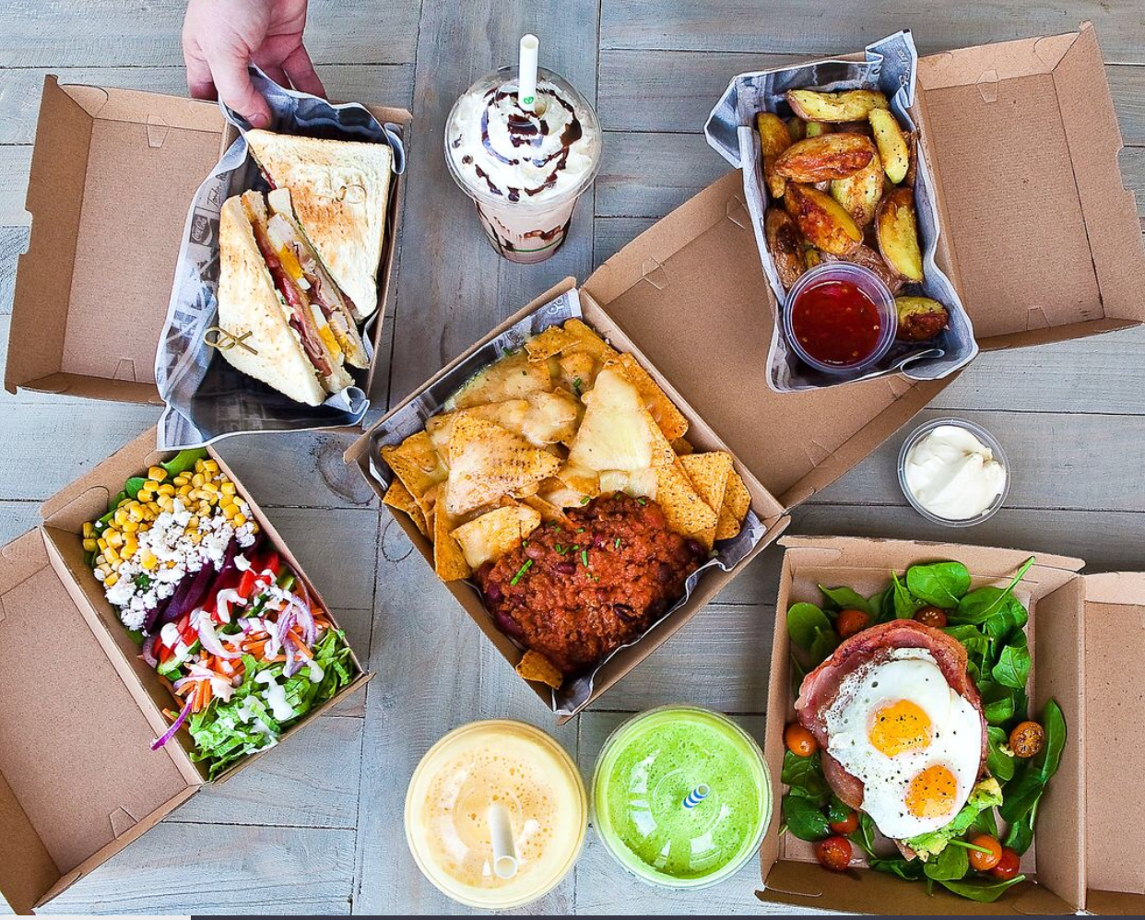

**Open 4-8pm every Friday**

Join us for a different culinary experience every Friday. Dine in or takeaway, Cafe is open for drinks and dessert, BYO wine or beer....

..come and chill out with us.

**@coffeecancafe**

**Coffee_Can_Cafe**

**28 Michaelangelo Drive, Redlynch**

**Tel: 0434 906 171**

**Open from 0630 hrs**

Homemade and tasty, baked on site or by some of Cairns’ best home bakers. Only the best local ingredients used wherever possible and locals supporting locals. Enjoy our speciality coffee, lovingly prepared by our friendly staff. We also stock only the best daily basics...

Brumby’s Bread, Mungalli Milk, Mungalli Eggs and Newspapers.

Fri 1 Mar… Smok’n’Steel

Fri 8 Mar… Tony’s Pizza

Fri 15 Mar… Spud Head

Fri 22 Mar… Hungry Nomad

Fri 29 Mar… Samosa Hub

Fri 5 Apr… Susies German Sausages

Fri 12 Apr… Smok’n’Steel

Fri 19 Apr… Tony’s Pizza

Fri 26 Apr… Richard’s Salt and Pepper

Fri 3 May… Samosa Hub

Café